

**PROJECT REPORT**

TETRIS GAME

Sunny Jovita

2301939046

FACULTY OF COMPUTER SCIENCE

BINUS INTERNATIONAL UNIVERSITY

1. **PROJECT SPECIFICATIONS**
2. Abstract

Tetris game is a tile matching puzzle game and it is one of the popular computer games in the world. It usually plays on a board with 20 rows and 10 columns. The project will make the concept of tetris game more complicated by adding a backsound music, modify the directions of the falling block, and many else. There are seven shapes of tetris, and the block fall from top of the board to the rest of the bottom board. The user has to control the block by moving the block to the left or right and rotating clockwise, the player need to gain as many score point as possible by clearing lines, to continue to the next level. More lines have been cleared, the speed of the blocks increases, which means the user has less time to decide the best way in the later part of the game. Therefore, the user will be easier to make the wrong decision, and finally lose the game. This project was made using Python programming and the data will be transformed from binary numbers (0) into a shape of the blocks. All in all, everything worked as expected but a lot of design improvements is mentioned in the solution design.

1. Introduction

This project is a tetris game with a concept of falling blocks. It is an interesting game to play and have focused on the logic as well as the outlook. This report describe how to train the user or the player to play tetris in an efficient manner by selecting the features.

It was a good choice for the experimental object for study, because the game is easy enough to grasp, reduce some stress to the user, and is relatively simple to modify in terms of changing difficulty settings, game speed, etc. This project also include an extended modular programming in the more complex ways. Not only the user able to develop the tetris game, but also that whoever wants to study the logic may prove this useful. The game is declared “game over” if the block has reached the top in the tetris game window.

1. **SOLUTION DESIGN**

All the activity about the games will be saved in a class named TetrisApp. Inside the class there are so many important functions.

1. **The needs**

Before make the code, prepare the color, music, fonts, etc that will be used later.

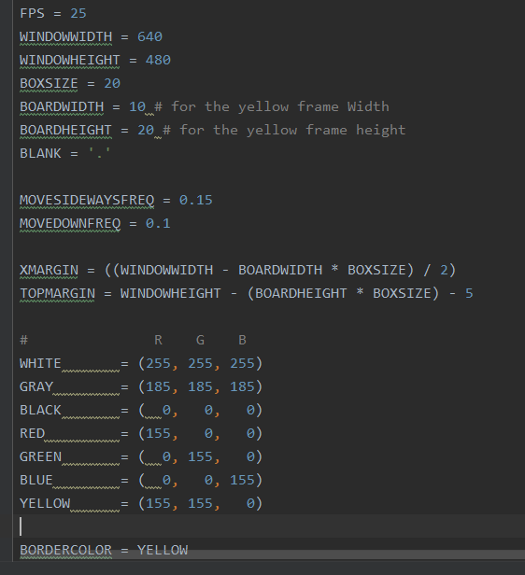

FPS makes the gameplay smoother because the blocks can move 1 pixel in every frame

1. **Cover display**

To make the title of the game, in the middle of the screen, define a function named showTextscreen. This function will display a large text(“Block Stacker”) in the screen, and make the text has shadow, until the key is pressed.

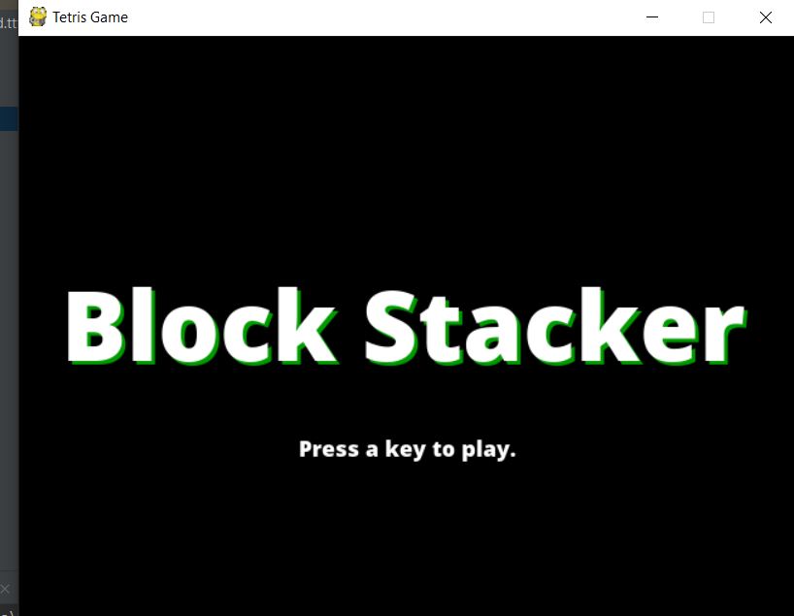 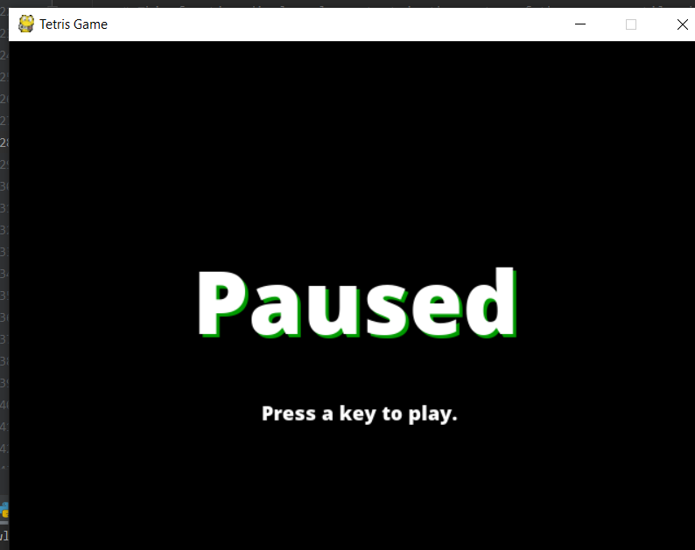

When you press the p button, the game will pause until u pressed any key to continue the game.

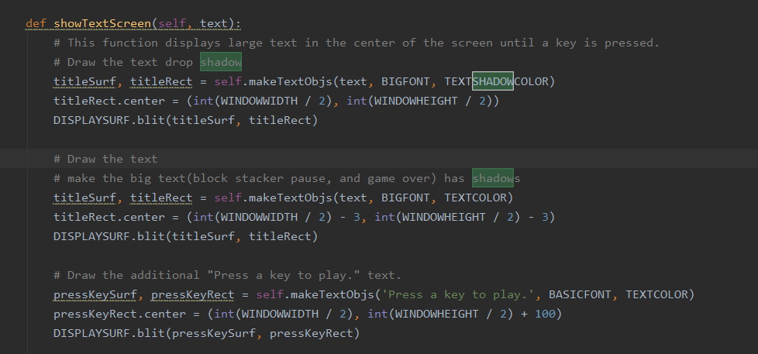

1. **Game display**

Make the screen with black color, inside the screen make a new frame for the block will fall later.

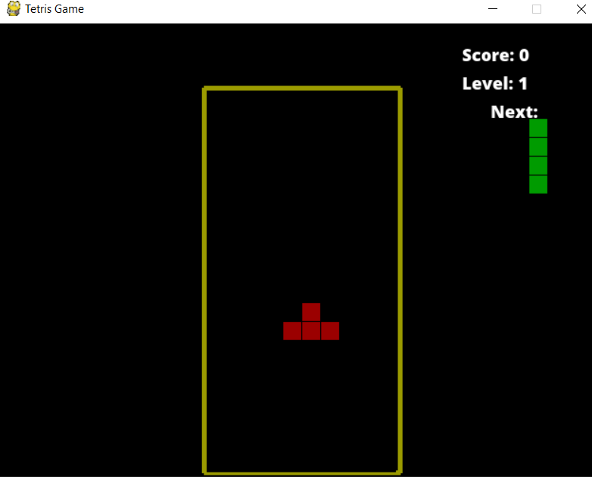

To make the piece/block out from the middle and appear in the screen, make a function called drawPiece. For draw the next pieces, just make the new function called drawNextPiece. The function of pixel x and pixel y are to show the location of the piece/block rotate according to the coordinate x and y. 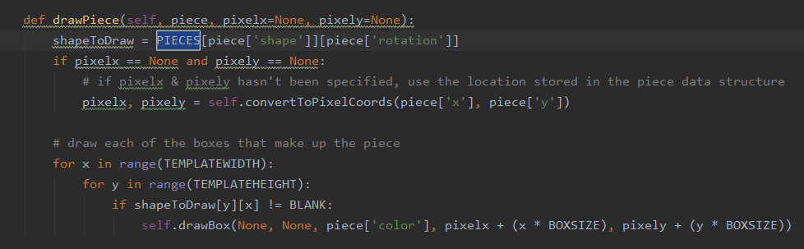

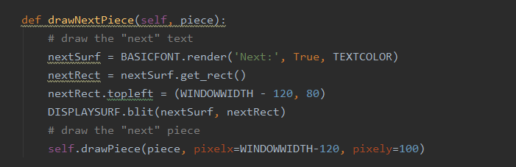

1. **DISCUSSION (how the Tetris works)**
2. MODULE

Module is a file consisting of python code. Module can define functions, classes and also variables. Modules can also include runnable code.

This project used some kind of modules. Most of the modules have already learnt in the class. There was random module (for random the color of the blocks that will be fallen, random the shape of the blocks), time module (handle the game related tasks(the time of the screen on, etc)), pygame module(because this project created a game, so definitely need this module, it imports all the pygame modules into the pygame package.), sys module(provides functions and variables used to manipulate different parts of the Python runtime environment.), add a new one module (from pygame.locals import*) this module is a pygame package. Used when you want to make a game through python code. This is an optional module(it is filled with functions you call frequently.

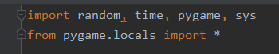

1. MAIN FUNCTION

Inside the main function there are many activities : display text and the background color, adding the backsound music, updating the game state, drawing the current state of the screen, handling the events, and so on. In this function, it displays the important outlook for the game : FPSCLOCK(it is a frame rate, and it dictates how smooth things are), DISPLAYSURF(display the screen weight and width), add fonts, backsound, and set the game name.

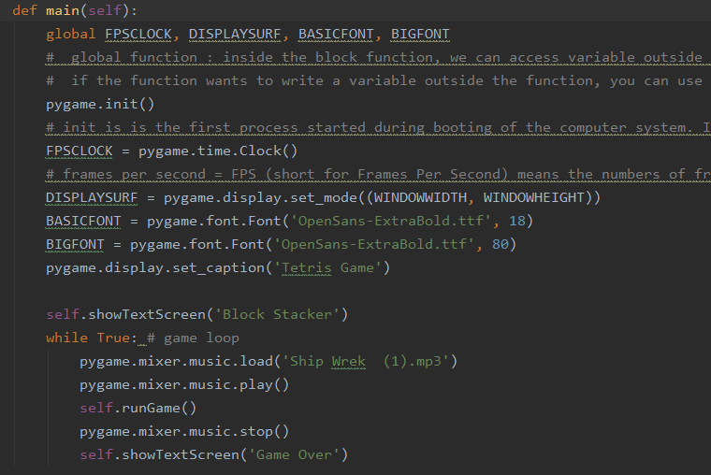

1. SHAPE PHYSICS

The Tetris grid is 640 cells wide and 480 cells tall. There are 7 shapes of tetris : “I”, “S”, “J”, “Z”, “T”, “L”, “O”.

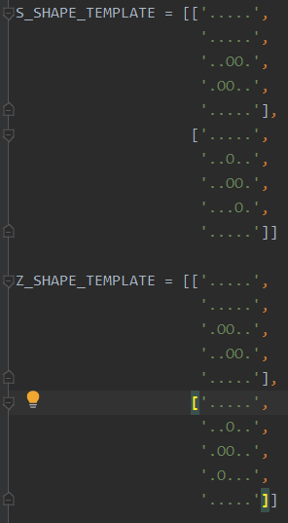

Make a shape with a list of binary numbers (0).

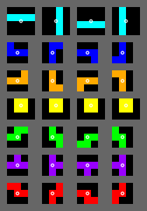

The illustrations of possible pieces and rotations.(clockwise)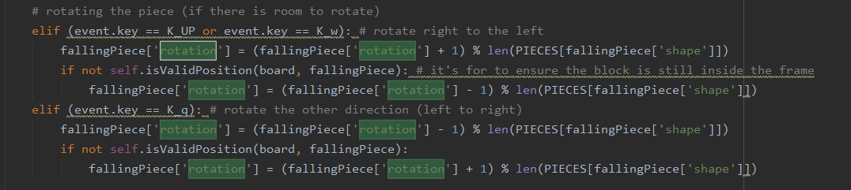The handling.event is used for all rotations.

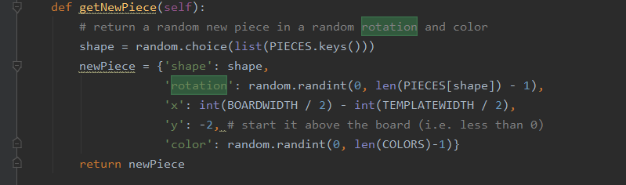

The getNewPiece function is used to randomize the next piece, the player don’t know what the next piece will be).

1. HANDLING EVENTS

Events in this game consist of everything that happens outside the control of the game's code but is relevant to the operation of the game. For example, if the player presses the left arrow key, the game needs to move the paddle to the left. Typical events are key presses (and releases), the pause button (p key), change the rotation (w, q, up arrow key button), make the block fall faster (using space key)

W, up arrow key = rotate the random block clockwise

A, left arrow key = shift the random block horizontally to the left

S, down arrow key = shift the random block vertically downwards

D, right arrow key = shift the random block horizontally to the right

Q = rotate the random block from the left to the right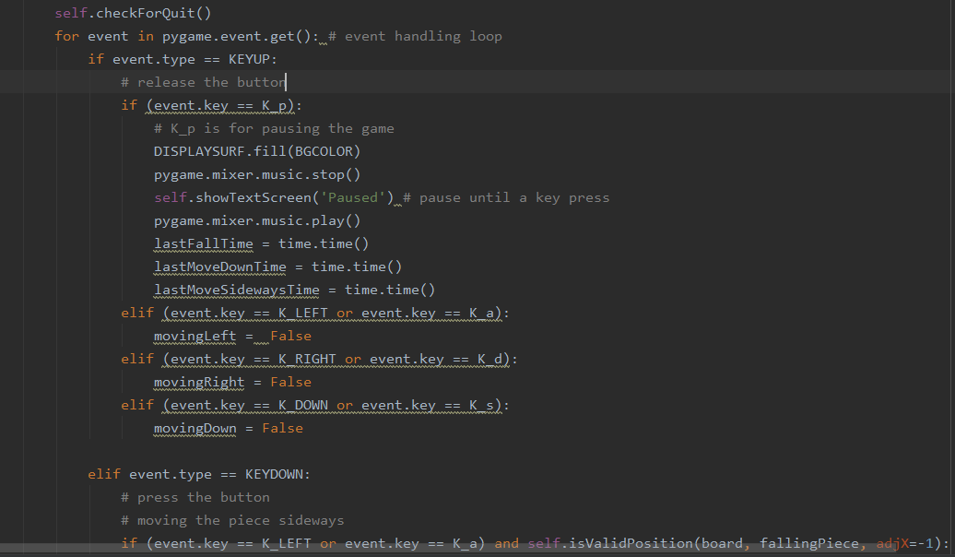

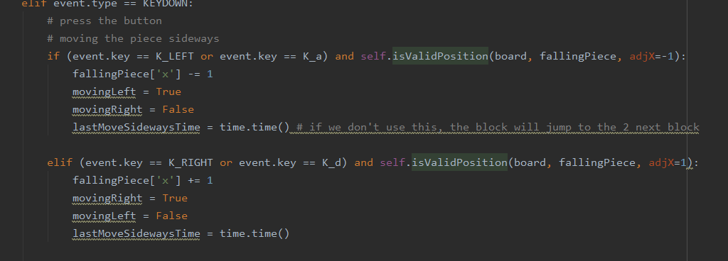

1. UPDATING STATE AND DRAWING

This part is for keep updating the block move and draws everything on the screen. In Breakout, the state includes the location of all the blocks, the position and speed of the blocks, as well as lives and the score. The game needs to display its state on the screen, this code includes drawing the block shape, and text.

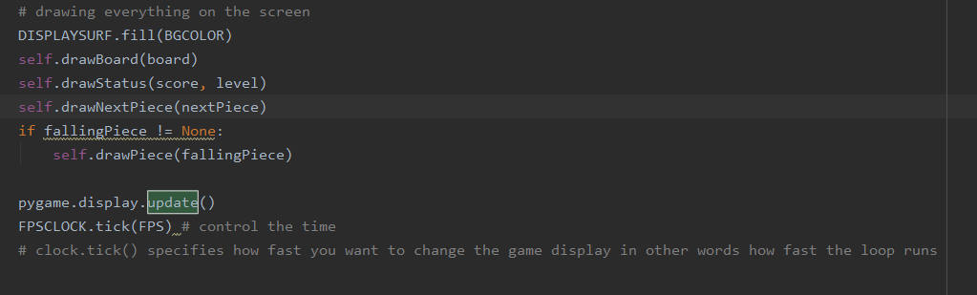



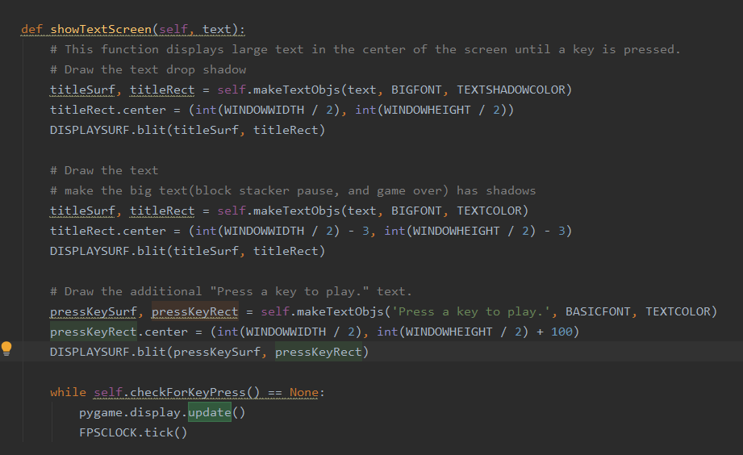

Update the screen and the FPS(frame per seconds) after draw everything and display everything that is needed on the screen. FPSCLOCK.tick(), is a form of clock which steps the game one “tick” forward. Tick is the smallest time step(more smaller than seconds) which is about 1/60 second. After every tick, the block will move down according to the game speed or the player speed.

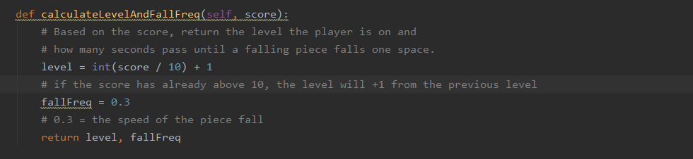

Calculate the blocks speed, and calculate the level using score (the level will increase (level+1) if the score has already above 10).

1. EXIT GAME

To quit the game, escape key button helps to quit the game immediately.

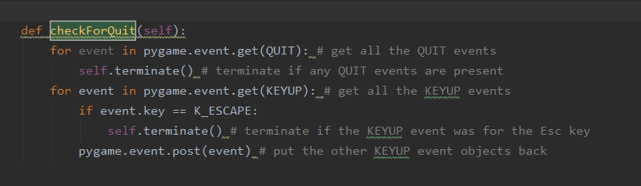

When the game is looping, the program will read the code from top to bottom. If the position is not in the right position, it will return by itself(the functions terminate or exit immediately) because it can’t fit a new piece on the board, the frame is fully loaded with the block, so it will display game over.

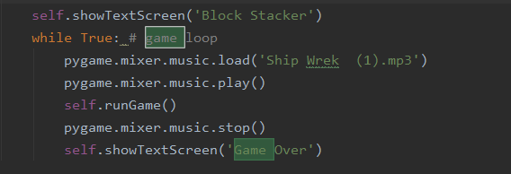 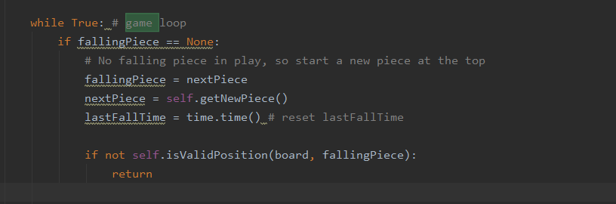

1. **CONCLUSION**

The game is up to the player to arrange all the falling blocks so that they(the blocks )line up in perfect rows, without holes. If a perfect row or the row is already full filled with the block, the row will disappear from the play field or the screen and the player rewarded with score points. The player gains more points depending on how many perfect rows that the player can create at the game. the game ends when the block can not fit again inside the frame. Finally all the data will recorded as well as every keyboard interaction of the player.